Jason Vaughan
527 Broadway
Sacramento, CA 95816
415-336-6116
jason@jasonvaughan.com

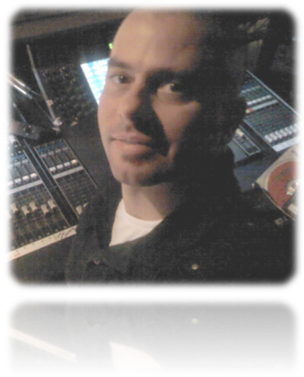
_{Objective:}
Seeking a free-lance or full time production/management position with a busy event center or production company. I enjoy technical challenges and working with talented colleagues and state of the art equipment. My passion is learning new technologies and putting my skills to use.

Technical Education
Barco Screen Pro, Encore and FSN Certifications
San Francisco Recording Institute Graduate
Pro Tools 9 Professional Recording Studio
Barco, Level A Video Engineering Certficate
Many years of “on the job” training via IATSE Local 16, 50 and 134
Microsoft Windows Media Service Provider Certified
Citrix XEN Server Virtualization Certified
Citrix XEN Desktop Certified
Cisco Certified Network Design Associate Certified
Sun Workstation and Enterprise Certified
Certified Microsoft Office Trainer
College Math and Linux Classes
Designed and built a scalable internet server / render farm
Designed a turnkey webcasting system in use by Government and Universities

Professional Experience
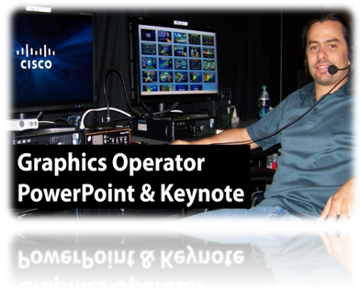
Freelance Graphics Designer / Video Engineer

June 1998 – Present
RIVERVIEW SYSTEMS GROUP Millpitas, CA

I am a long term contractor for Riverview Systems Group, a well known bay area boutique A/V company. I interface directly with CEOs, CFOs, EVPs, VPs and assistants to create or revise their presentations with my expert knowledge of PowerPoint, Keynote, PDF and other Adobe applications. I’m known for my quick work, and ability to act decisively under a high pressure production environment.

Audio Technician, Video Engineer, Webcast Technician, 1998 – 1999
Networking / Computer Technician, Multisource Technician, & 2010 - Present
Graphics Operator and Camera Operator

IATSE, LOCAL 16 San Francisco, CA


I have worked for several A/V companies in many capacities via my relationship with the International Alliance of Theatrical Stage Employees Union (IATSE) in San Francisco, Sacramento and San Jose. I’ve set up booth exhibits, complex video walls, LCD & LED Walls, Projectors, Lighting, Sound Reinforcement Systems, Backlined / ran monitor and main mix’s for bands, was the technical lead for Webcasts and Networking installations, and prepared steward reports. I have also operated both fixed and boom camera systems, in house and small lighting controllers, and video servers. I’m well known in the industry for my technical skills, quick learning abilities and work ethic. I’m requested frequently by clients who want me on their shows. If you need someone who knows how to work within union provisions, I’m your man.

Onsite Service Engineer, I/T Specialist March 2000 – Present
J. BURTON AND ASSOCIATES, INC West Sacramento, CA

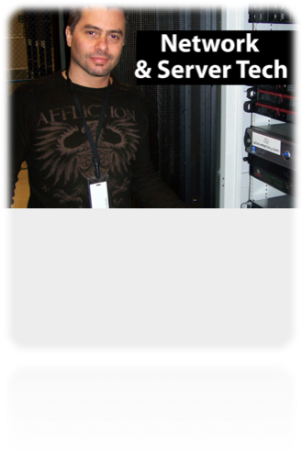
J. Burton and Associates (JBA) provides technology services for conventions and trade shows. I’ve worked as a lead event technician on events throughout the United States, Europe and Asia. JBA provides private networks, large scale WAN installations, VLANS, large scale DHCP services, computer / peripheral rentals, lab setup and management, speaker ready rooms, onsite enterprise wireless, internet and support for Keynote and Track sessions,etc.

I’ve worked all positions at JBA. A specialty of mine is to setup and manage the speaker ready room. Speaker Ready Room is the place a speaker arrives and works on his or her presentation. I help with whatever technical assistance they might need, including power point / keynote, pdf, graphic design, video, animations, etc. I also compile and distribute the presentations to the remote meeting rooms and act as a lead technician with supervisory responsibility. I’ve managed crews up to 20 people (union and non union).

Program Event Producer 1992-1996
ROSIE PRESENTS San Francisco, CA

Rosie Presents was a promotion agency specializing in marketing / tradeshow events on a nationwide basis. My responsibilities included event planning, venue selection, sub-contracting, production meetings with clients, complex reporting, budget allocation, conflict resolution, technical direction and talent management. At Rosie Presents, my team was responsible for executing over 5,000 events in 4-years. Our clients included Remy Amerique, Bacardi, Lucky Strike, Marlborough, Diageo and others.

Additional

San Francisco Territory Manager 1997
ACROPOLIS SYSTEMS, INC Milpitas, CA

Acropolis Systems Inc (ASI is now ”Bscaler” a SAAS firm) was a systems integrator focused on the fortune 100 market. ASI provided highly available (HA) systems to banks, oil companies, manufacturers, etc. HA systems provide over 99.999% uptime for mission critical applications. Additionally, we focused on Y2K compliance. I was the territory manager based at 1 Embarcadero. The named accounts in my book were responsible for 10M in sales during the year I was there. I setup meetings, identified opportunities, prepared detailed proposals, ROIs, case studies, networked with manufacturer reps and partners, and - MOST importantly - was able to get purchase orders from customers thus closing the deal. ASI had annual revenue of 36M in 1997.

Co-Founder / Investor 1997-2007
FRNK TECHNOLOGY GROUP, INC Scotts Valley, CA

I co-founded the FRNK Technology Group, a thinktank / development firm for web-based technologies. I designed systems utilizing state of the art software to offer turn key web applications as a service (or Software As A Service / SAAS). This was long before anyone else had even thought of it. I designed and produced a system for fully integrated and automated webcasting. This system is still in use today by Universities and Government agencies. My team also produced the first form of social networking just after 2000 implemented through adult community membership websites. We were pioneers in the field. While I was fairly active during the beginning years of this company, my involvement transitioned into a board position until the company finally sold in 2007.

Owner 2008-2011
LIVE RECORDING AND SOUND Sacramento, CA

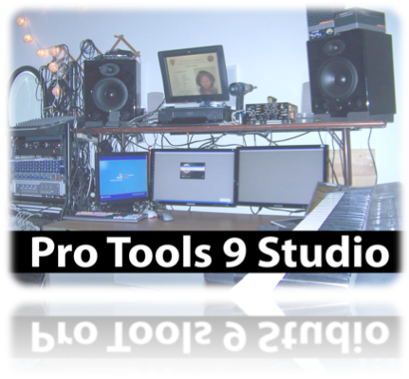
It took me a year of planning but I designed, built and now operate a fully equipped 128 Track Pro Tools 10 / Mutlitrack tracking / mixing studio in Sacramento used in my multimedia projects.

Studio Milestones;

- Engineered and Produced 2 albums
- Engineered and Produced radio bumps
- Pitch correction projects
- Drum replacement projects
- Video soundtrack projects
Pre Sonus – ACP88
AKG 414 G / Stereo pair
Mesa Boogie Triaxis
Rocktron Multi-valve
Alesis Quadraverb
EL Labs Distressor
Neumann U87
Millenia TD1
Korg Triton Studio 88
Mackie 32x8 Mixer with Metered Bridge

Partial gear list:

References
You are more than welcome to contact my references to inquire about my work experience. I am happy to share email addresses or phone numbers by request.

James Burton / J.Burton and Associates http://jburton.com
John Haworth / Riverview Systems Group http://riverview.com
Marc Kaplan / Riverview Systems Group http://riverview.com
Kevin Ricks / Hampton University, VA – Media Services Dept. http://www.hamptonu.edu
Gene Goodwin / WYCG – County of York, VA http://yorkcounty.gov
Jack Chin / City and County of San Francisco, CA – SFGOVTV http://sfgovtv.org
Mike Neeley / Projection, Moscone Center http://www.projection.com
Simon Tuck / Projection, Moscone Center http://www.projection.com
Mark Pace / CTO, Jolokia Networks http://www.jolokianetworks.com
David Carminito / Business Agent IATSE Local 16 http://local16.org
Steve Lutge / Business Agent IATSE Local 16 http://local16.org
Bill Jakab / Technical Director, Jack Morton http://jackmorton.com
Carol Bailey / Producer, Big Show Productions http://bigshowpro.com
Casey Hiester / Producer, Invision http://iv.com
Suzanne McKaig / Producer, Group X http://groupx.com
Sean Von Seeger / Project Manager, Creative Technology US http://ctus.com
Alan Bagshaw / Technical Director, Bagshaw & Associates http://bagshaw.net

